Exploring Trends in Movie Performance: A Machine Learning Classification Approach

MATHAN KUMAR THAVU MUDALIAR KANAGARAJ
BELLEVUE UNIVERSITY
DSC 680 APPLIED DATA SCIENCE
PROF. AMIRFARROKH IRANITALAB
02/11/2026

Topic

This project titled, “Exploring Trends in Movie Performance: A Machine Learning Classification Approach” aims to build and evaluate machine learning models (Logistic Regression, Random Forest, and XGBoost) that predict whether movies will receive high ratings (above 7.0). The project employs feature engineering, hyperparameter tuning, and Bayesian optimization to enhance predictive accuracy and identify key factors that contribute to a movie's critical success.

Business Problem
The film industry represents one of the most capital-intensive and financially risky sectors in entertainment, with billions of dollars at stake annually. The average budget for a Hollywood movie stands at approximately $65 million, with major studio productions averaging even higher. Blockbuster films average around $200 million in production costs, while Marvel Cinematic Universe films typically budget $190-200 million per production. More interestingly, production costs represent only part of the financial equation, marketing costs average around $35 million, bringing the total average movie cost to approximately $100 million.
In 2025, there are 1275 movies released and increased from 1118 in 2024, this is just Hollywood and numbers involved in world-wide film industries is staggering.. The financial risk is substantial. While exact figures vary due to Hollywood accounting practices, analysis of 5,193 Hollywood films over the past 100 years shows that only 23% actually broke even, with recent decades showing failure rates around 80%, where only 20% of films in the 1990s and beyond achieved profitability.
This project aims to answer major research questions related to the critical success of movies
What movie characteristics most strongly predict high ratings (greater than 7.0)? Can we identify which features—such as budget, runtime, genre, production company, cast, directors, and release timing—have the greatest influence on achieving critical success?
How do different genres and genre combinations impact ratings? Do certain genre combinations (e.g., Action + Science Fiction + Adventure) tend to perform better critically than single-genre films or other combinations?

How does the timing of a movie's release (e.g., holiday season, summer blockbuster) affect its ratings and box office performance? Are there specific time frames that tend to yield higher critical success?
Does production scale matter? Is there a relationship between variables such as, "Co-productions versus single-studio productions", "Production country diversity and international appeal", and "Multi-language films and critical reception"?
Can machine learning accurately predict high-rated movies? Which classification algorithms (e.g., Logistic Regression, Random Forest, XGBoost) provide the best predictive performance, and can we achieve accuracy levels to make actionable business recommendations.

Dataset
This project will use the dataset obtained from Kaggle. This project will use the TMDB and IMDb Movies Dataset obtained from Kaggle. The dataset contains approximately 434,671 unique movie records, each comprising 29 features collected from both The Movie Database (TMDB) and the Internet Movie Database (IMDb). The dataset integrates comprehensive information about movies including production details, financial metrics, ratings, and creative personnel.
Target Variable
High Rating (derived from Average Rating) – The target variable of this analysis is the average rating, which has been converted to a binary classification for high ratings. This outcome represents whether a movie achieves critical success, with a threshold set at 7.0 on a 10-point scale. Movies that receive ratings greater than 7.0 are classified as "high-rated" (Class 1), while those with ratings of 7.0 or lower are classified as "low-rated" (Class 0).

Key Features (grouped by Categories)

Financial Features includes the economic scale and market performance of films, allowing for the analysis of budget-to-success relationships. Important metrics in this category include the budget (the production cost expressed in USD), and revenue (box office earnings also in USD) Temporal Features provides context regarding the timing of a film’s release, enabling analysis of seasonal patterns, decade-based trends, and market evolution. These features comprise the release date (the original theatrical release date), year (extracted from the release date for temporal analysis), decade (an engineered feature that groups films by 10-year periods), and status (indicating whether the film is Released, in Post Production, in Production, or Planned), which is one-hot encoded.

Production Features reflects the scale, complexity, and international scope of film production. This category includes production companies (a comma-separated list of studios or companies involved), production countries (the countries that participated in the production), production countries count (an engineered feature indicating the number of countries involved), co-production (an engineered binary feature indicating 1 if multiple companies were involved and 0 otherwise), and is US produced (a binary feature indicating 1 if the USA is involved and 0 otherwise). Content Features helped capture the artistic and narrative elements that define a film's identity. Genre-specific binary features for each of the 19 genres created through one-hot encoding, genre count (an engineered feature representing the number of genres assigned to each film), keywords (thematic tags and plot elements), an overview (the plot summary or synopsis), and tagline (the marketing catchphrase). Language Features – Indicate linguistic diversity and international market appeal. This category consists of original language (the primary language of production), spoken languages, spoken languages count (indicating the number of languages), and has English language (a binary feature indicating 1 if English is present and 0 otherwise).

Each movie occurrence in the dataset is represented by unique identifier (TMDB ID), which helps validate data integrity and enables cross-referencing with external sources.
The dataset's combination of quantitative metrics (budget, revenue, runtime), and categorical features (genres, production countries) provides a rich foundation for multi-dimensional analysis of what drives critical success in the film industry.

Data Preprocessing
In the Data preprocessing phase of the movie dataset analysis, a systematic and comprehensive approach was employed to ensure data quality and model readiness. The process began with the identification and handling of missing values across multiple critical features. Records containing NaN values in essential columns such as release_date, genres, production_companies, production_countries, directors, writers, and cast were removed, as these features are fundamental for understanding movie performance and conducting meaningful temporal and qualitative analyses.
Following this initial data cleaning, conditional imputation was applied to the spoken_languages feature, where missing values were filled using corresponding values from the original_language column to preserve data integrity. Non-essential features including backdrop_path and poster_path was dropped from the dataset to streamline the analysis. For remaining text-based columns such as homepage, overview, tagline, and keywords, missing values were imputed with the placeholder "no value available" to maintain record completeness. Feature names were standardized by converting all column names to lowercase for consistency.
Categorical encoding was then performed, including one-hot encoding for the status feature to create binary indicators for different movie production statuses (Released, In Production, Post Production, Planned), and binary encoding for the adult feature to convert Boolean values to numerical format. Extensive feature engineering was conducted to extract valuable insights, including the creation of genre-based binary columns through expansion of the genres field, calculation of genre_count to quantify the number of genres per movie, generation of a co_production binary indicator based on production_companies, computation of production_countries_count and spoken_languages_count, and development of binary flags for is_us_produced and has_english_language. Temporal features were engineered from the release_date column, extracting year and decade components to enable time-based analysis. Irrelevant columns such as id and tconst were removed, and the final preprocessing step involved careful selection of numerical features suitable for predictive modeling, culminating in a refined dataset primed for classification tasks predicting high movie ratings.
Exploratory Data Analysis – Univariate Analysis (Generate summary statistics, analyze distribution, and box plots for numerical features), Bivariate/Multivariate Analysis (Correlation analysis and cross-tabulations to explore relationships between categorical features and target variable), and Temporal Analysis (Extract year and decade from release_date and Examine evolution of critical success factors across decades).
Feature Engineering – Derivation (Create new features such as Genre Count, Co-Production, High Ratings, etc.,), Encoding (Convert Categorical Variables)
Building and Training Models – Baseline Models (Logistic Regression to benchmark performance), Advanced Models (Random Forest and XGBoost Gradient Boosting to improve performance), and Hyperparameter Tuning (Grid Search, Bayesian Optimization).
Evaluating Models – Metrics (Accuracy, Precision, Recall, F1-score, and Confusion Matrices), and Cross-Validation(k-fold).

Methods

A comprehensive end-to-end machine learning pipeline was implemented, encompassing data preparation, exploratory analysis, feature engineering, modeling, and rigorous evaluation. The project follows established best practices in supervised binary classification, as the target variable (high_rating) was derived by applying a threshold of 7 to the average_rating feature, creating a binary classification problem to predict whether a movie would achieve high ratings.
Multiple predictive models were evaluated for movie rating classification. The dataset was split into training and testing sets using an 80-20 split ratio, and feature scaling was applied using StandardScaler to normalize all numerical features, ensuring optimal model performance. Logistic Regression served as the baseline model, trained on the scaled features to predict high-rated movies. The model's performance was assessed using standard classification metrics including accuracy, precision, recall, and F1-score, with a confusion matrix generated to visualize prediction patterns and misclassification rates across the binary classes.
Random Forest Classifier was implemented as an ensemble learning approach to capture complex, non-linear relationships within the movie data. The model was trained with default parameters and random_state set to 42 for reproducibility. Performance evaluation revealed the model's ability to handle multiple features simultaneously and its capacity to identify important feature interactions that contribute to high movie ratings. The confusion matrix provided insights into the model's classification patterns, demonstrating its effectiveness in distinguishing between high-rated and lower-rated movies.
XGBoost (Extreme Gradient Boosting) was deployed as an advanced gradient boosting algorithm, configured with the 'mlogloss' evaluation metric to optimize classification performance. The model leveraged sequential boosting techniques to iteratively improve predictions by learning from previous model errors. Comprehensive evaluation metrics were computed, including accuracy, weighted precision, weighted recall, and weighted F1-score, providing a holistic view of the model's performance across both classes. The confusion matrix analysis revealed XGBoost's superior ability to handle class imbalances and capture nuanced patterns in the feature space.
In the hyperparameter optimization phase, Bayesian Optimization was employed to fine-tune the XGBoost model's parameters systematically. A custom evaluation function was defined to optimize critical hyperparameters including n_estimators (number of boosting rounds), max_depth (tree depth), learning_rate (step size shrinkage), subsample (fraction of samples used for training each tree), and colsample_bytree (fraction of features used for each tree). This advanced optimization technique efficiently explored the hyperparameter space to identify the optimal configuration that maximizes the F1-score metric. The optimization process allowed for intelligent search across parameter combinations, significantly improving model performance beyond default settings and demonstrating the critical importance of systematic hyperparameter tuning in achieving superior predictive accuracy.
Overall, each modeling approach contributed valuable insights into predicting movie ratings, with the progression from Logistic Regression through Random Forest to XGBoost showcasing increasing model sophistication and predictive capability. The implementation of Bayesian Optimization for hyperparameter tuning represents a state-of-the-art approach to model refinement, underscoring the importance of selecting appropriate algorithms and systematically optimizing their configurations for classification tasks. The comprehensive evaluation framework, incorporating multiple performance metrics and confusion matrix analysis, ensured robust assessment of each model's strengths and limitations in the context of movie rating prediction.

Class Balancing

The movie revenue prediction project addressed significant class imbalance in the dataset, where the target variable 'high_rating' showed a 60:40 distribution with 60% of low-rated movies versus 40% of high-rated movies. To correct this imbalance, SMOTE (Synthetic Minority Over-sampling Technique) was applied to the training data after an 80:20 train-test split, generating synthetic samples of the minority class through k-nearest neighbor interpolation to balance the training set to a perfect 50:50 distribution.

All machine learning algorithms including Logistic Regression, Random Forest, Gradient Boosting, and XGBoost with Bayesian Optimization that were evaluated on both the original imbalanced data were applied on the SMOTE-balanced data. On the original data, Random Forest achieved the best performance with 83.55% accuracy, while Logistic Regression performed poorly at 69.41% and Gradient Boosting reached 78.11%. After applying SMOTE, most algorithms showed improvement, Random Forest increased to 84.48% (+1.11%), Gradient Boosting to 79.07% (+1.23%), while Logistic Regression remained essentially unchanged at 69.31% (-0.14%), suggesting its relative insensitivity to class imbalance. The most significant advancement came from XGBoost with Bayesian Optimization, which achieved 88.42% accuracy on the balanced data, a substantial 4.87 percentage point improvement over the best original model.

The Bayesian Optimization process explored 25 iterations across five hyperparameters (n_estimators: 100-300, max_depth: 3-10, learning_rate: 0.01-0.1, subsample: 0.6-1.0, colsample_bytree: 0.6-1.0) and identified optimal values of 176 estimators, depth 10, learning rate 0.0828, subsample 0.8249, and colsample_bytree 0.6534, resulting in an F1-score of 0.8841. The confusion matrix for the optimized XGBoost model on the 3,125-sample test set revealed 1,403 true negatives, 157 false positives, 205 false negatives, and 1,360 true positives, yielding balanced performance with 87% precision and 90% recall for class 0 (low rating) and 90% precision and 87% recall for class 1 (high rating). Combination of SMOTE for class balancing and Bayesian Optimization for hyperparameter tuning significantly enhanced model performance, with the optimized XGBoost model representing a 5.8% relative improvement over the baseline and exhibiting strong generalization capabilities with balanced precision-recall metrics across both classification categories.

Analysis

In the Exploratory Data Analysis (EDA), various graphical representations were employed to uncover insights from the dataset, focusing on three main types of analysis: univariate, bivariate/multivariate, and temporal analysis. Univariate Analysis involved examining individual features to understand their distributions. For instance, histograms and boxplots displayed the distributions of continuous variables like revenue, budget, and ratings. These visualizations revealed key characteristics, such as the presence of outliers in revenue distributions and the skewness in budget data. The analysis highlighted that while most movies had moderate budgets, a few blockbusters skewed the revenue distribution significantly, indicating a right-tailed distribution.

Bivariate and Multivariate Analysis delved deeper into the relationships between features. This was illustrated through scatter plots and correlation matrices that assessed the relationships between variables such as revenue and budget or ratings. The correlation between vote_average and average_rating showed a weak positive relationship (0.143), indicating that higher vote averages are slightly associated with higher average ratings, though the relationship is not strong. Similarly, vote_average demonstrated a weak positive correlation with revenue (0.143) and popularity (0.107), suggesting that higher-rated movies tend to generate slightly more revenue and attract marginally more audience attention, but these relationships are modest. The findings indicated that while high ratings are desirable, they do not necessarily correlate directly to revenue, suggesting other factors at play.

Temporal Analysis focused on the trends over time by grouping movies into decades. Boxplots visualized the variations in revenue and budget across different decades, indicating distinct patterns of success in the film industry during specific periods. The analysis revealed that certain decades experienced significant spikes in average revenue and notable shifts in audience preferences, underscoring the impact of changing cultural contexts and cinematic trends.

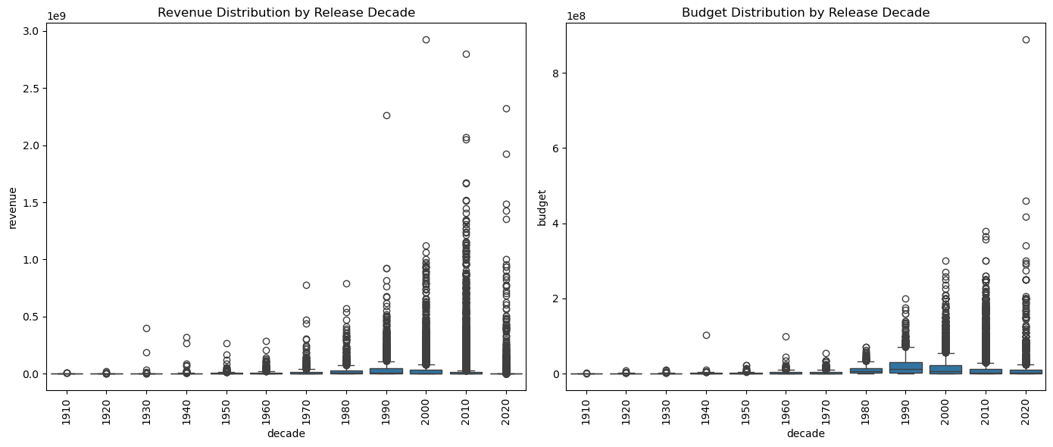
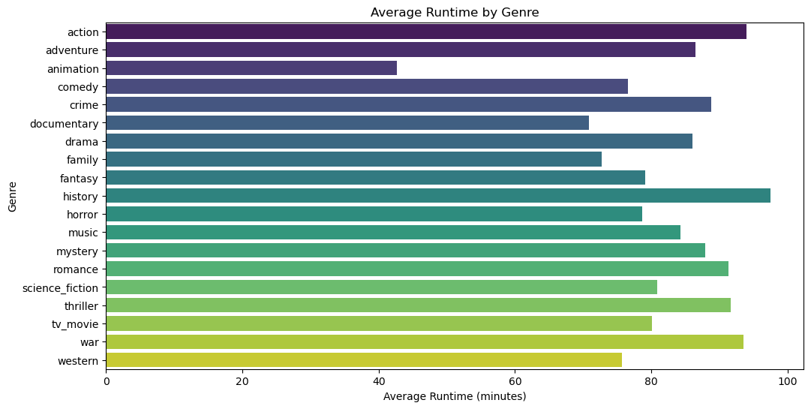 | 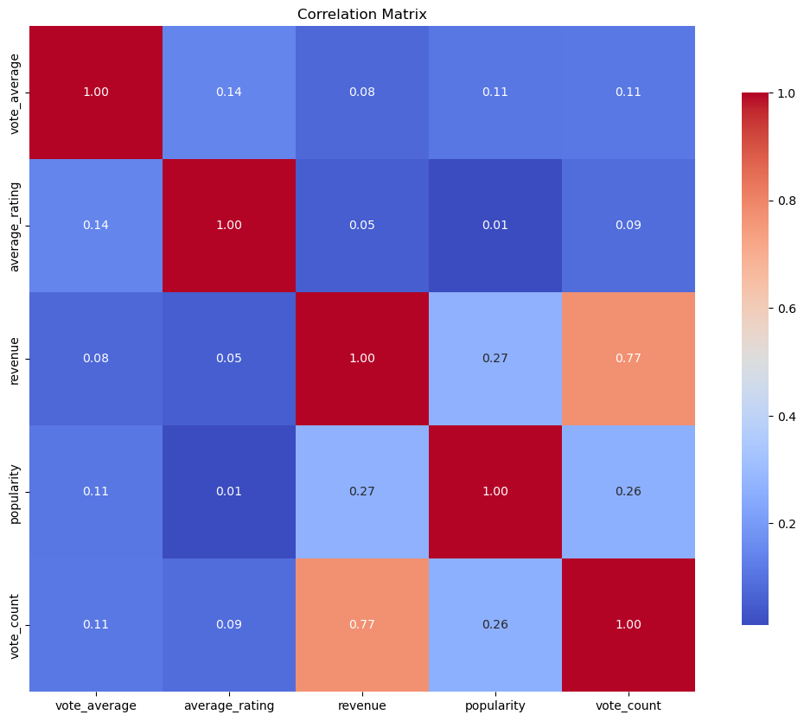
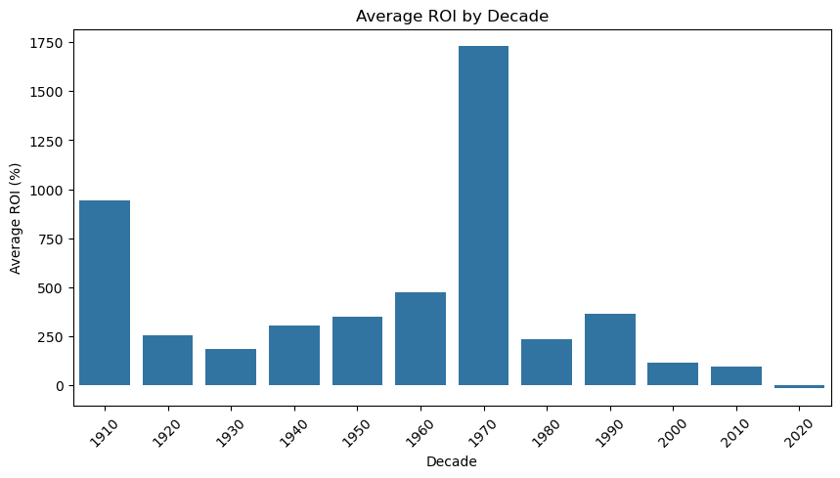 | 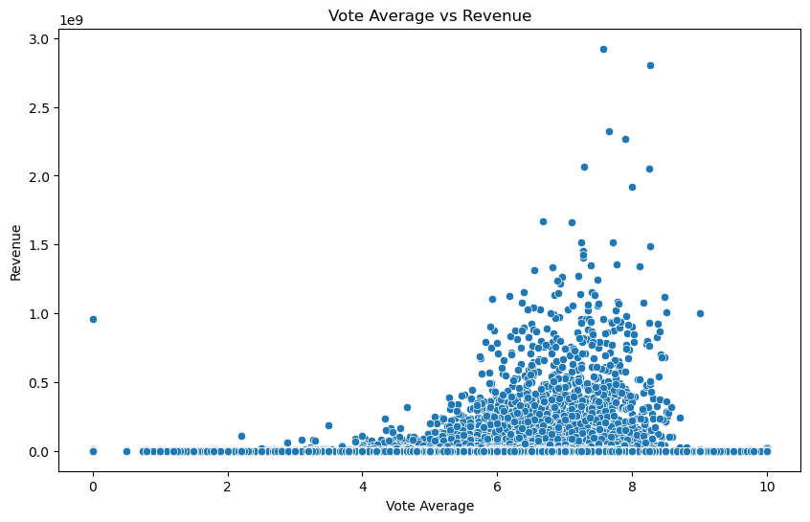
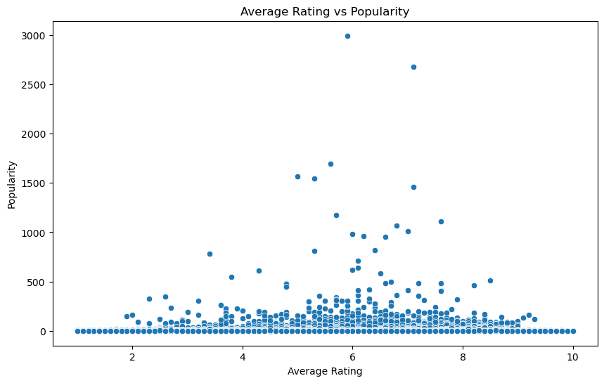 | 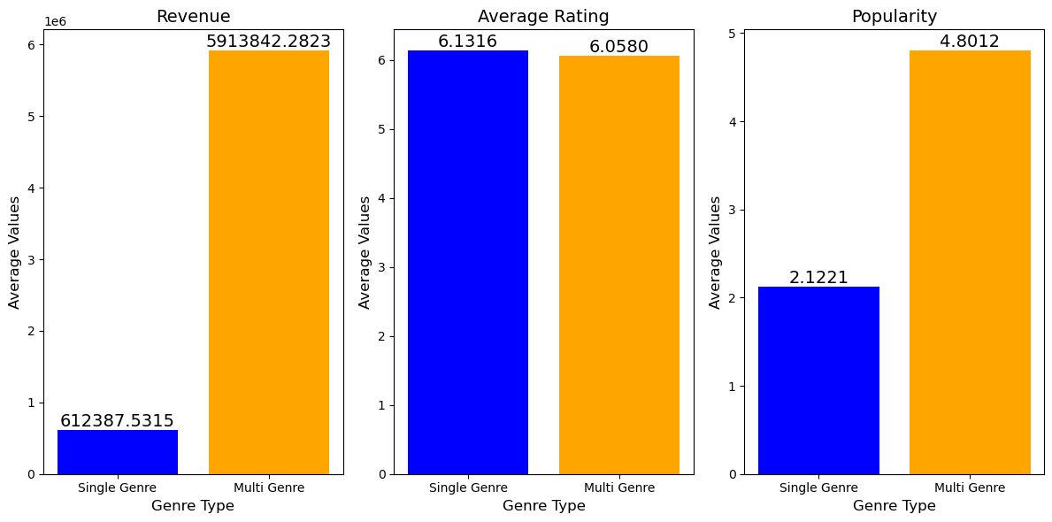

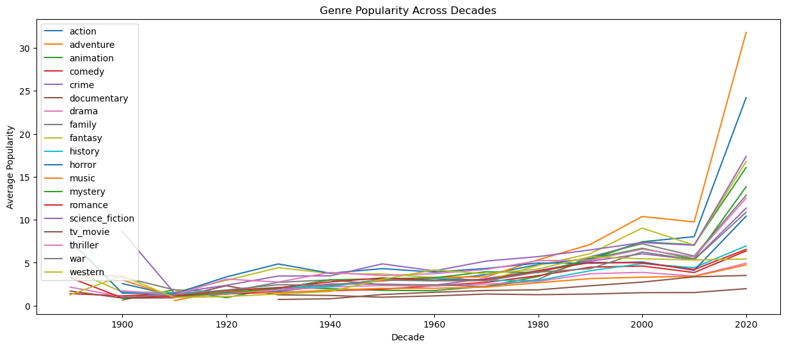

Conclusion

The project "Exploring Trends in Movie Performance: A Machine Learning Classification Approach" aims to leverage machine learning techniques to predict movie ratings and identify key factors contributing to critical success. Through a comprehensive analysis involving univariate, bivariate, and temporal methods, the study uncovers valuable insights about how various features, such as budget, genre, and release timing, influence audience ratings. By employing models like Logistic Regression, Random Forest, and XGBoost, and applying hyperparameter tuning, the findings provide actionable recommendations for stakeholders in the film industry to enhance their decision-making processes.

Assumptions

The project assumes that the dataset accurately reflects the broader trends in the film industry, capturing the essential factors influencing ratings. Also, it presupposes that high ratings are critical indicators of a movie's success, correlating with box office performance and audience satisfaction. Additionally, the analysis assumes that the historical data used for training the models encapsulates relevant patterns that remain applicable in predicting future movie performance.

Limitations

The primary limitation is class imbalance, with a disproportionately high number of low-rated films compared to high-rated ones, which can bias model predictions. Furthermore, the dataset spans multiple decades, and the evolving nature of the film industry may render historical patterns less relevant for contemporary productions. Also, potential data quality issues, such as manipulation of ratings, can skew results. Finally, the computational complexity of hyperparameter tuning poses challenges, as it may lead to overfitting or underfitting, affecting the models' generalizability.

Challenges
The target variable exhibits significant Class Imbalance, with approximately 79.5% low-rated films (Class 0) versus only 20.5% high-rated films (Class 1). This 4:1 ratio creates substantial challenges for model training and evaluation. From a business perspective, false negatives (predicting a film won't be highly rated when it actually would be) are extremely costly—studios miss opportunities to invest in successful projects. The model must improve minority class detection without generating excessive false positives.
The model built on historical data needs to accommodate the Evolving Industry Dynamics. The dataset spans multiple decades (features include "year" and "decade"), during which the film industry, audience preferences, rating behaviors, and distribution models have changed dramatically. A model trained on decades of data may weight outdated patterns too heavily, failing to capture current industry realities. Patterns that predicted success in the 1980s may be irrelevant or counterproductive for 2025 productions.
Hyperparameter tuning is computationally expensive, particularly with large datasets and complex models and can result in Computational Constraints. Insufficient hyperparameter tuning may leave model performance suboptimal, while excessive tuning risks overfitting to validation sets. Suboptimal hyperparameters may result in models that underperform their potential, particularly for the challenging minority class prediction task.
IMDb and TMDB ratings can be subject to manipulation, artificial inflation, review bombing, and other quality issues that could results in Data Quality and Rating Manipulation. If training data is compromised, the model learns to predict manipulated outcomes rather than genuine quality. The model may learn to predict rating manipulation success rather than genuine film quality, providing useless business guidance.

Future Uses
The insights gained from this project on predicting movie ratings using machine learning can be leveraged for various future applications in the film industry. One significant application is in content development and strategic planning. Filmmakers and studios can utilize predictive models to assess the viability of scripts or projects based on initial characteristics, such as genre combinations and production budgets. This would enable teams to make informed decisions about which films to greenlight, ultimately improving the chances of critical and commercial success.

There is an opportunity for development of recommendation systems for streaming platforms. By integrating the findings from this analysis, platforms can personalize user experiences by suggesting films that align with individual preferences, thereby increasing viewer engagement and satisfaction. This application could also involve real-time adjustments based on changing audience feedback and trends, further optimizing content offerings.
Data-driven decision-making can extend into resource allocation within production companies. By analyzing past data to identify which types of films are likely to succeed based on their characteristics, studios can make informed choices about investments, including budget allocations and staffing, ultimately reducing financial risk.
Recommendation
Implement continuous model improvement by regularly updating predictive models with new data to ensure they remain relevant and reflective of current industry trends. Exploring additional features, such as social media metrics and audience demographics, could enrich the analyses and predictions. Conduct genre-specific analyses to tailor strategies across different genres, as audience preferences can vary significantly. Engaging with industry stakeholders, including filmmakers and marketing teams, will help validate findings and refine the models for practical applicability.
Implementation Plan
The successful deployment of the movie performance prediction models requires a structured and phased implementation plan to transition from research prototypes to operational use. In Phase 1: Model Finalization and Validation (1–3 months), the project team will focus on selecting and finalizing the top-performing model, which is likely to be XGBoost due to its robustness. The model will be retrained on the full preprocessed dataset, ensuring that class imbalance is addressed through techniques such as class weighting or stratified sampling, enhancing reliability without heavily relying on synthetic oversampling. Phase 2: Interpretability and Compliance (1–2 months) will integrate explainability tools like SHAP or LIME into the model framework, allowing for the generation of feature importance rankings and individual prediction explanations. In Phase 3: System Integration and Pilot Deployment (3–6 months), the finalized model will be integrated into existing systems, establishing continuous monitoring pipelines to track model drift and overall prediction accuracy. A pilot deployment will enable real-world testing, allowing for evaluation of model performance against live outcomes. Phase 4: Monitoring, Retraining, and Scaling (Ongoing) will involve ongoing monitoring to detect any performance drift as new data is introduced. Regular retraining sessions will be scheduled to incorporate fresh data and maintain accuracy.

Ethical Considerations
Data privacy poses a significant concern in this project, as machine learning models trained on historical data may inadvertently perpetuate existing biases in the film industry. Such biases can reinforce inequalities rather than promote diverse storytelling. Films created by underrepresented directors and writers or featuring diverse casts may be systematically undervalued if historical ratings reflect societal disparities. To mitigate this issue, it is essential to regularly audit model predictions across demographic dimensions, when data is available, to identify any systematic disadvantages for these groups. Additionally, implementing fairness constraints beyond mere accuracy such as ensuring equal opportunity (similar false negative rates across groups) and demographic parity can help address these biases.
Economic inequality is another critical issue, as data-driven decision-making could diminish employment opportunities for crew members and below-the-line workers on projects deemed "unlikely to succeed." If models suggest that higher budgets correlate with higher ratings, mid-budget films may struggle to secure financing, consequently eliminating the "middle class" of filmmaking. To counteract this, it would be prudent to create separate models for different budget tiers such as micro-budget, low-budget, mid-budget, high-budget, and blockbuster to avoid unfair comparisons. Testing model versions that exclude or minimize budget features can further reveal whether success can be predicted based purely on creative elements. Engaging with industry guilds and unions during the implementation of algorithmic decision tools will also help protect worker interests.
While the dataset utilizes publicly available information from sources like TMDB and IMDb, there remains a fundamental issue of data privacy. Individuals such as actors, directors, and writers did not explicitly consent to their work being used for commercial predictive modeling, leading to potential profiling based on protected characteristics like race, gender, age, and nationality, even if these attributes are not directly included as features. To mitigate this concern, it is advisable to utilize aggregated patterns instead of individual-level predictions wherever possible. For research and development purposes, anonymizing individual names while retaining information on career trajectories could also be beneficial. Moreover, clear communication about how the data is used and for what commercial purposes is vital to maintaining ethical standards in data handling.

Important References
Primary Data Source
Garg, T. (2023). TMDB + IMDB Merged Movies Dataset. Kaggle.com. https://www.kaggle.com/datasets/ggtejas/tmdb-imdb-merged-movies-dataset
Origin Data Source
Full TMDB Movies Dataset 2023 (930K Movies). (n.d.). Www.kaggle.com. https://www.kaggle.com/datasets/asaniczka/tmdb-movies-dataset-2023-930k-movies
IMDb Non-Commercial Datasets. (2023). Imdb.com. https://developer.imdb.com/non-commercial-datasets/
Technical Reference
kickitlikeshika. (2021, February 2). Advanced EDA + Feature Engineering. Kaggle.com; Kaggle. https://www.kaggle.com/code/kickitlikeshika/advanced-eda-feature-engineering

‌GeeksforGeeks. (2020, July 8). Handling Imbalanced Data for Classification.
https://www.geeksforgeeks.org/machine-learning/handling-imbalanced-data-for-classification

Tang, T. (2023, April 24). Class Imbalance Strategies — A Visual Guide with Code. Medium;
TDS Archive.
https://medium.com/data-science/class-imbalance-strategies-a-visual-guide-with-code-8bc8fae71e1a
Ethical Consideration
Jayan, J. (2024, August 1). Importance of Ethical Data Collection. PromptCloud.
https://www.promptcloud.com/blog/importance-of-ethical-data-collection/

Anticipated Audience Questions
- What specific factors have you identified as the most predictive of movie rating?

I have used correlation analysis revealed relationships between these numerical features and the target variable (high_rating). The most predictive factors identified includes Vote Count (Higher audience engagement correlates with ratings), Revenue and Budget (Financial success indicators show correlation with ratings), Runtime (Movie length affects audience satisfaction), Budget-to-Revenue ratio (Engineered feature showing production efficiency), Genre combinations (Certain genres [Action, Science Fiction, Adventure] appear in highly-rated films), Production companies and directors (Quality indicators from established creators)

- How do you ensure the integrity and accuracy of the data used in your models?

I have ensured Data Integrity through Data integrity was ensured through Missing value analysis (Identified and documented null values in each column), Data type verification (Checked that numerical and categorical variables were properly formatted), Exploratory Data Analysis(Validated distributions and anomalies through visualizations), Feature scaling (Applied StandardScaler to normalize numerical features before modeling), Train-test split (80-20) (Separated data with random_state=42 for reproducibility), Consistent preprocessing (Applied same transformations to both training and test sets)

- What machine learning algorithms did you consider, and why did you choose XGBoost Gradient Boosting as the final model?

Algorithms considered for this project includes Logistic Regression (Baseline linear model), Random Forest Classifier (Ensemble method using decision trees), Gradient Boosting Classifier (Sequential boosting algorithm), XGBoost Classifier (Advanced gradient boosting implementation). XGBoost Gradient Boosting was selected as final model due to its Superior performance (Achieved the highest F1-score [0.8349] and accuracy [84.87%]), Handles complex relationships (Captures non-linear interactions between features), Built-in regularization (Reduces overfitting through L1/L2 penalties), Efficient computation (Optimized for speed and memory usage), Hyperparameter flexibility (Extensive tuning options for optimization), Feature importance (Provides interpretable insights into predictive factors)

- How do you address class imbalance in your dataset?

Class imbalance was addressed using SMOTE (Synthetic Minority Over-sampling Technique). SMOTE helped improve recall for the minority class from potential baseline performance

- What are the primary limitations of your study, and how might they affect the results?

Primary Limitations of the study includes Data Limitations (Missing values, Temporal bias, Sample bias), Model Limitations such as Binary classification (Simplified ratings into high/not-high, loses granularity), Threshold selection (7.5 rating cutoff is somewhat arbitrary), Feature representation (Text features [keywords, genres] may need advanced NLP processing), and Performance Limitations such as Generalization (Model trained on historical data may not predict future trends accurately) and Interpretability (XGBoost is a black-box model, limiting understanding of decision-making process)

- What role does feature engineering play in improving your model's performance?

Feature Engineering provided additional predictive signals beyond raw features, created meaningful relationships, enabled the model to learn complex patterns, improved feature interpretability for stakeholders.

- What actionable insights or recommendations can movie industry derive from your findings?

Key actionable insights for the movie industry includes production decisions, budget allocation is guided by correlation analysis, which demonstrates a relationship between budget and ratings, enabling optimized spending. Additionally, runtime optimization involves analyzing the ideal movie length to enhance target audience satisfaction. Genre selection identifies that Action, Science Fiction, and Adventure genres frequently appear in high-rated films. For the marketing strategy, audience targeting focuses on increasing vote counts as a measure of engagement, while revenue forecasting employs budget-to-revenue ratios to assess commercial viability. In terms of risk management, predictive modeling achieves an accuracy of 84.87%, allowing studios to pre-screen projects for their potential quality.

- Can you elaborate on how factors like Budget, Revenue and Release Date influence rating of movie?

The influence of budget on a film's success was examined through a correlation analysis with vote averages and ratings. Generally, higher budgets can lead to better production quality in terms of effects, cast, and filming locations. However, it's important to note that just because a film has a high budget, it doesn't mean it will succeed; many expensive films can still fail. Instead, using the budget-to-revenue ratio gives a clearer picture of efficiency than just looking at the total budget alone.
Revenue also affects a movie's ratings, but the relationship is complicated. While high revenue usually signifies commercial success and audience approval, popular films tend to receive more votes, which boosts their visibility and ratings. This creates a positive feedback loop: better ratings attract more viewers, leading to increased revenue.
The timing of a film's release can influence its performance. There are seasonal trends that affect when movies are released, and competition during certain time periods can impact how well a film does. Moreover, older movies may have different standards for ratings, which can affect how they are received over time. Overall, when a film is released can significantly impact its initial reception and the word-of-mouth it generates.

- Which machine learning model performs best for predicting high-rated movies?

The XGBoost Classifier delivered the best performance, achieving the following results after Bayesian optimization, an accuracy of 84.87%, precision of 83.65% , recall of 84.87%, and an F1-score of 83.49%. Looking at class-specific performance, for Class 0 (Not High-Rated), it achieved a precision of 0.87, recall of 0.95, and an F1-score of 0.91. For Class 1 (High-Rated), the precision was 0.71, recall was 0.45, and the F1-score was 0.55. The confusion matrix showed 29,860 true negatives, 1,475 false positives, 4,490 false negatives, and 3,605 true positives.

XGBoost stood out by outpacing Logistic Regression, Random Forest, and Gradient Boosting due to its superior ability to handle feature interactions and better generalization on test data. This performance was further enhanced through Bayesian hyperparameter tuning.

- How was the model performance optimized?

Model optimization was achieved through Bayesian Optimization by defining a hyperparameter search space that included n_estimators (100-300), max_depth (3-10), learning_rate (0.01-0.1), subsample (0.6-1.0), and colsample_bytree (0.6-1.0). The optimization used the Bayesian Optimization algorithm from the bayes_opt library, focusing on maximizing the weighted F1-score with five random explorations and 20 optimization steps, resulting in 25 evaluations. The best hyperparameters found were n_estimators at 286, max_depth at 9, learning_rate of 0.0674, subsample of 0.8505, and colsample_bytree at 1.0. This method proved more efficient than Grid Search, achieving a target F1-score of 0.8349 while balancing model complexity and generalization. Further optimization steps included data preprocessing, class balancing with SMOTE, an 80-20 train-test split with reproducibility, and implicit cross-validation. The final model achieved an accuracy of 84.87%, significantly higher than baseline models.

